## **Objectives**

* Explain various ways of conditional rendering
* Explain how to render multiple components
* Define list component
* Explain about keys in React applications
* Explain how to extract components with keys
* Explain React Map, map() function

In this hands-on lab, you will learn how to:

* Implement conditional rendering in React applications

## **Prerequisites**

The following is required to complete this hands-on lab:

* Node.js
* NPM
* Visual Studio Code

## **Notes**

Estimated time to complete this lab: **60 minutes.**

Create a React App named “bloggerapp” in with 3 components.

1. Book Details
2. Blog Details
3. Course Details

Implement this with as many ways possible of Conditional Rendering.

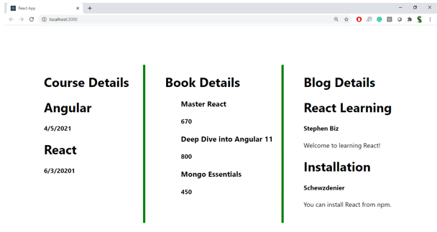

**Hint:**

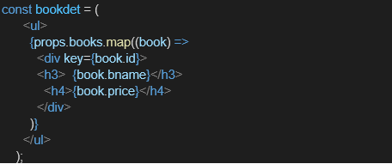

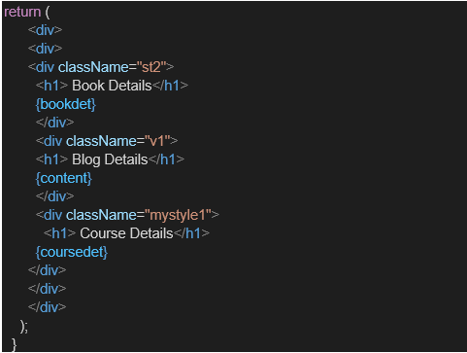

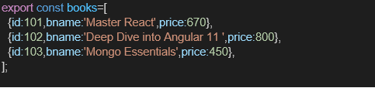

**Program:**

**App.js:**

import React, { useState } from 'react';

import BookDetails from './components/BookDetails';

import BlogDetails from './components/BlogDetails';

import CourseDetails from './components/CourseDetails';

function App() {

const [active, setActive] = useState('book');

const renderComponent = () => {

if (active === 'book') {

return <BookDetails />;

} else if (active === 'blog') {

return <BlogDetails />;

} else if (active === 'course') {

return <CourseDetails />;

} else {

return <p>Please select a section to view.</p>;

}

};

return (

<div style={{ padding: '20px' }}>

<h1>📚 Blogger App</h1>

<div style={{ marginBottom: '20px' }}>

<button onClick={() => setActive('book')}>Book Details</button>{' '}

<button onClick={() => setActive('blog')}>Blog Details</button>{' '}

<button onClick={() => setActive('course')}>Course Details</button>

</div>

{/* Conditional Rendering using function */}

{renderComponent()}

</div>

);

}

export default App;

**BookDetails.js:**

import React from 'react';

const books = [

{ id: 1, title: "React Explained", author: "Zac Gordon" },

{ id: 2, title: "Learning JavaScript", author: "Ethan Brown" },

{ id: 3, title: "Effective TypeScript", author: "Dan Vanderkam" }

];

const BookDetails = () => {

return (

<div>

<h2>📘 Book Details</h2>

<ul>

{books.map(book => (

<li key={book.id}>

<strong>{book.title}</strong> by {book.author}

</li>

))}

</ul>

</div>

);

};

export default BookDetails;

**BlogDetails.js:**

import React from 'react';

const blogs = [

{ id: 1, title: "Understanding React Hooks", date: "2023-06-10" },

{ id: 2, title: "JavaScript ES6 Features", date: "2023-07-15" },

{ id: 3, title: "CSS Grid vs Flexbox", date: "2023-08-01" }

];

const BlogDetails = () => {

return (

<div>

<h2>📝 Blog Details</h2>

<ul>

{blogs.map(blog => (

<li key={blog.id}>

{blog.title} (Posted on {blog.date})

</li>

))}

</ul>

</div>

);

};

export default BlogDetails;

**CourseDetails.js:**

import React from 'react';

constcourses = [

{ id: 1, name: "React Basics", duration: "4 Weeks" },

{ id: 2, name: "Advanced JavaScript", duration: "6 Weeks" },

{ id: 3, name: "Full Stack Development", duration: "12 Weeks" }

];

const CourseDetails = () => {

return (

<div>

<h2>📚 Course Details</h2>

<table border="1" cellPadding="8">

<thead>

<tr>

<th>Course</th>

<th>Duration</th>

</tr>

</thead>

<tbody>

{courses.map(course => (

<tr key={course.id}>

<td>{course.name}</td>

<td>{course.duration}</td>

</tr>

))}

</tbody>

</table>

</div>

);

};

export default CourseDetails;

**index.js:**

import React from 'react';

import ReactDOM from 'react-dom/client';

import App from './App';

const root = ReactDOM.createRoot(document.getElementById('root'));

root.render(<App />);

**Output:**

